Geometric Dilution of Precision (GDoP) for Range Difference of Arrival (RDoA): Mathematical Formulations and Derivations

Abeer N. Chaudhry
This document provides a brief mathematical foundation for computing Geometric Dilution of Precision (GDoP) in a sensor network using Range Difference of Arrival (RDoA). It covers the mathematical expressions for directional derivatives, the Jacobian matrix, the error covariance matrix, the Fischer Information, and finally the GDoP computation.
GDoP quantifies how the geometric configuration of a set of sensors relative to a source (or emitter) affects the precision of the resulting location estimate. It measures the impact of the geometry of the sensor network or array on the uncertainty in position estimation. The more spread out and ideally positioned the sensors are (i.e., not too close together and spread across a wide area), the lower the GDoP, which translates to better position accuracy. A low GDoP value indicates that the geometry is favorable for accurate positioning, while a high GDoP suggests a configuration that results in poor positioning accuracy.
GDoP is the Cramer-Rao Lower Bound (CRLB) when it comes to localization and parameter estimation problems. It describes the lower bound of estimation accuracy given the measurement noise and the system geometry.

1. Range Difference of Arrival (RDoA) Concept
In an RDoA-based localization system:
- Absolute Range: The distance from an emitter/source to a sensor is represented as:
$$r_{i}=\left\|x-x_{i}\right\|$$
Where:
- $r_{i}$: Range from source x to sensor i
- x : Position vector of the emitter/source
- $x_{i}$: Position vector of sensor ii
- ∣∣⋅∣∣: Euclidean norm
Range Difference: The difference in ranges between two sensors (test sensor and reference sensor) is:

$$Δr_{ij}=r_{i}-r_{j}=\left\|x-x_{i}\right\|-\left\|x-x_{j}\right\|$$
The RDoA introduces a differential measurement, which inherently correlates the noise of two measurements from shared sensor contributions.

2. Directional Derivatives for Range Difference
The directional derivative quantifies how a small change in the emitter position ($x$) affects the range difference measurement.
For the range difference:
$$Δr_{ij}=\left\|x-x_{i}\right\|-\left\|x-x_{j}\right\|$$

Taking the partial derivatives with respect to the emitter position:
$$\begin{aligned}&\frac{∂Δr_{ij}}{∂x}=\frac{x-x_{i}}{\left\|x-x_{i}\right\|}-\frac{x-x_{j}}{\left\|x-x_{j}\right\|} \\ &\frac{∂Δr_{ij}}{∂y}=\frac{y-y_{i}}{\left\|x-x_{i}\right\|}-\frac{y-y_{j}}{\left\|x-x_{j}\right\|}\end{aligned}$$

These derivatives describe how the range difference changes with respect to emitter location shifts in the x and y directions.

3. Jacobian Matrix for RDoA Measurements
The Jacobian matrix (J) relates changes in emitter position to variations in range difference measurements. Each row of the Jacobian corresponds to one sensor pair (test sensor and reference sensor):
$$J=\left[\frac{x-x_{i}}{\left\|x-x_{i}\right\|}-\frac{x-x_{j}}{\left\|x-x_{j}\right\|}\frac{y-y_{i}}{\left\|x-x_{i}\right\|}-\frac{y-y_{j}}{\left\|x-x_{j}\right\|}\right]$$

For multiple sensor pairs, the Jacobian can be expanded as:
$$J=\left[\begin{matrix}\frac{Δx_{i}}{R_{i}}-\frac{Δx_{j}}{R_{j}} & \frac{Δy_{i}}{R_{i}}-\frac{Δy_{j}}{R_{j}} \\ ⋮ & ⋮\end{matrix}\right]$$
Where:
- $Δx_{i}=x-x_{i}$
- $R_{i}=\left\|x-x_{i}\right\|$(distance to sensor i)
- $Δy_{i}=y-y_{i}$
This Jacobian captures the geometric relationship between source location changes and the resulting RDoA measurements.

4. RDoA Error Covariance Matrix
The error covariance matrix describes the statistical noise properties of the range difference measurements. When using RDoA, noise contributions from sensors are correlated.

4.1 Error Variance and Covariance
For two range measurements:
- Variance of range difference:
$$Var\left(Δr_{ij}\right)=Var\left(r_{i}\right)+Var\left(r_{j}\right)=σ^{2}+σ^{2}=2σ^{2}$$
- Covariance between two different range differences $(Δr_{ij})$ that share a common sensor:

$$Cov\left(Δr_{ij},Δr_{ik}\right)=σ^{2}$$

4.2 Covariance Matrix Representation
For a system with multiple sensor pairs, the covariance matrix can be expressed as:
$$R_{RDoA}={c^{2}σ}^{2}\left[\begin{matrix}2 & 1 & 1 & ⋯ & 1 \\ 1 & 2 & 1 & ⋯ & 1 \\ 1 & 1 & 2 & ⋯ & 1 \\ ⋮ & ⋮ & ⋮ & ⋱ & ⋮ \\ 1 & 1 & 1 & ⋯ & 2\end{matrix}\right]$$
Where;
$c$ is the speed of EM propagation and $σ^{2}$ is the RMS measurement error in time. This conversion is required in the event the errors are calculated in time differences and not in range differences.

- Diagonal terms represent total noise variance ($2σ^{2}$) from two independent range measurements.
- Off-diagonal terms represent shared noise contributions ($σ^{2}$).

5. Position Error Covariance Matrix (Dilution Matrix)
The position error covariance matrix (Q) also known as the inverse of the Fischer Information Matrix (FIM) is derived from the Jacobian and the error covariance matrix:
$$Q={\left(J^{T}R^{-1}J\right)}^{-1}$$
Where:
- $J^{T}$: Transpose of the Jacobian matrix
- $R^{-1}$: Inverse of the RDoA error covariance matrix
The matrix Q represents the uncertainty of the position estimate in terms of sensor geometry and noise characteristics.

6. Geometric Dilution of Precision (GDoP)
GDoP quantifies the overall uncertainty in position estimation due to sensor geometry. It is computed from the position error covariance matrix $(Q)$:
$$GDoP=\sqrt{trace (Q)}$$
Where:
- trace(Q): Sum of the diagonal elements of the covariance matrix
The GDoP value represents how measurement errors are amplified by the geometry of the sensor network.

7. Steps for GDoP Computation
- Sensor Geometry Definition: Place sensors and define positions.
- Range Difference Calculation: Compute $Δr_{ij}$ for all sensor pairs.
- Jacobian Formation: Derive the Jacobian matrix based on directional derivatives.
- Error Covariance Matrix: Construct the RDoA covariance matrix.
- Position Covariance Matrix: Compute Q using $Q={\left(J^{T}R^{-1}J\right)}^{-1}$.
- GDoP Calculation: Extract GDoP using trace(Q).

8. Impact of Changing the Reference Sensor on GDoP

GDoP represents a geometric property of the sensor network and emitter relative positioning, the practical computation of RDoA-based GDoP involves the reference sensor as an integral component. Changing the reference sensor affects the resulting dilution of precision due to the individual nature of its geometric relationship with other sensors in the network, the emitter and the noise correlation that propagates because of it into the covariance matrix. The practical implications result such that:
- Noise Correlation: Changing the reference sensor alters the noise terms that are shared between the pairs of measurements. This changes the covariance matrix structure resulting in the resampling of the matrix with the new indexing of elements per the selection of the reference sensor.

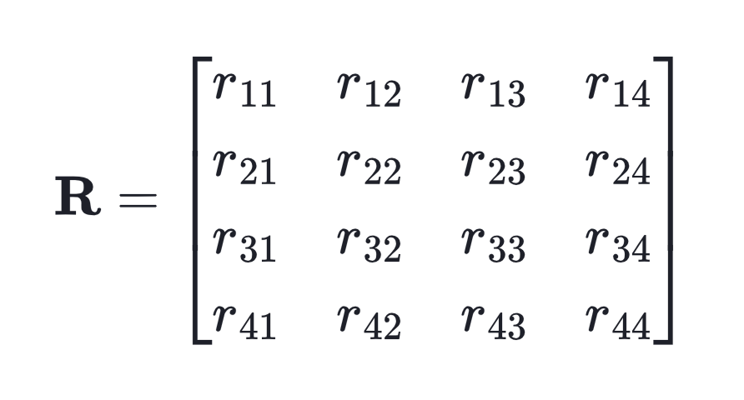

Considering there are 4 sensors in a network, $R$ is the covariance matrix with reference sensor chosen to be $i=1$. If the reference sensor was selected with the index $i=3$, the covariance matrix will have to be resampled. This can be done manually, or it can be done by performing permutation with each row of the permutation matrix representing the new order of the sensors and each row representing the original order of the sensors:

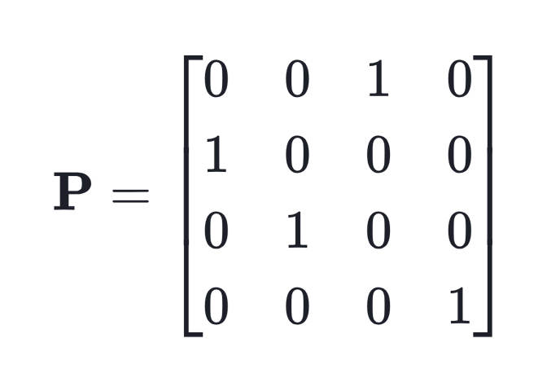

The new covariance matrix is created as:


For the example under consideration, the final expression after resampling/permutation becomes:
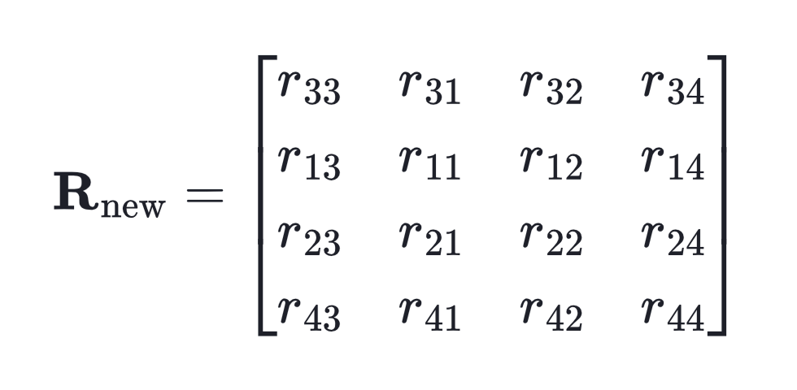
Note: It should be noted that the restructuring is necessary only if the sensors are differently weighed in their contribution.
  - Restructuring Process for the RDoA Covariance Matrix
While the above is true for GDoP that is calculated based on absolute range measurements, the same can be applied to the RDoA covariance matrix by implementing a linear transformation which reduces the ($N x N)$ matrix to a $(N-1 x N-1)$ matrix, where N is the number of sensors in the network. Range differences are measured from each sensor to the reference sensor $\left(r_{ref}\right).$ A range difference covariance matrix with $i=1$ as the reference sensor is given as:
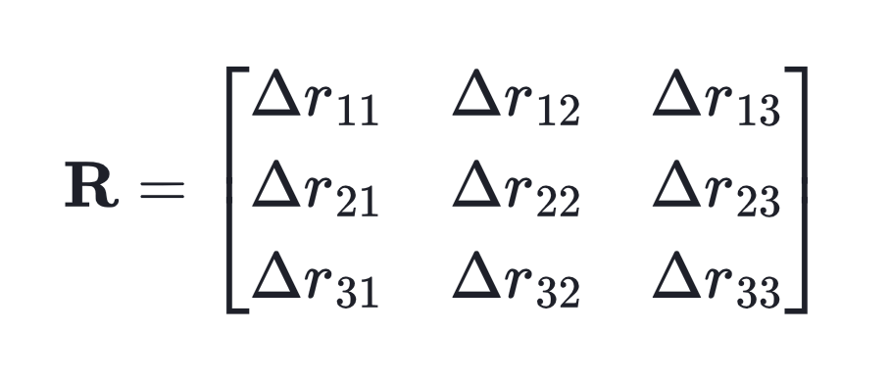
Where, $Δr$ is the range difference vector relative to sensor $r_{1}$ as:
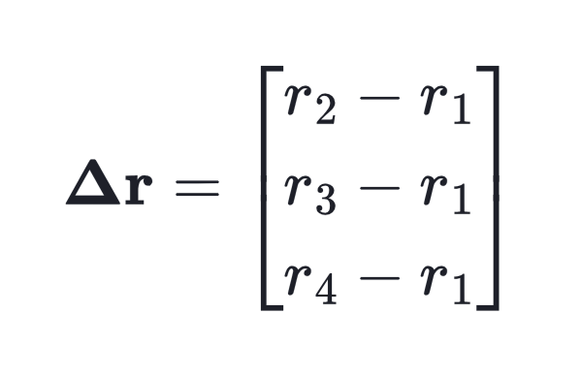
If the reference sensor were changed to $i=3$, the linear transformation would be expressed in terms of the difference operator matrix $P$, such that if we had a general matrix $r$ which represented the absolute ranges, then, range difference matrix with reference $i=3$ would be:
$$Δr=Pr$$
Where;
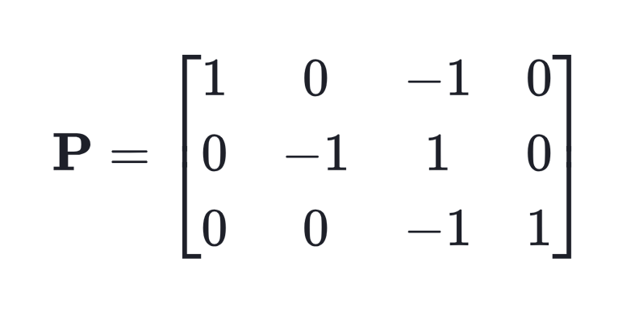
Yielding the following matrix:
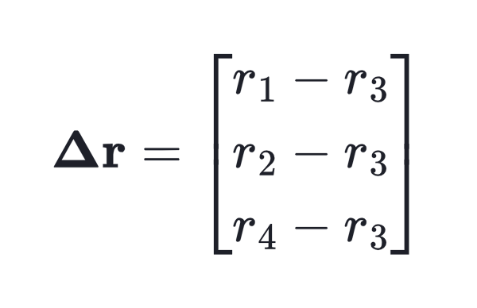
The linear transformation is applied to the range covariance matrix:
$$R_{new}=PRP^{T}$$
With the new RDoA covariance matrix being:
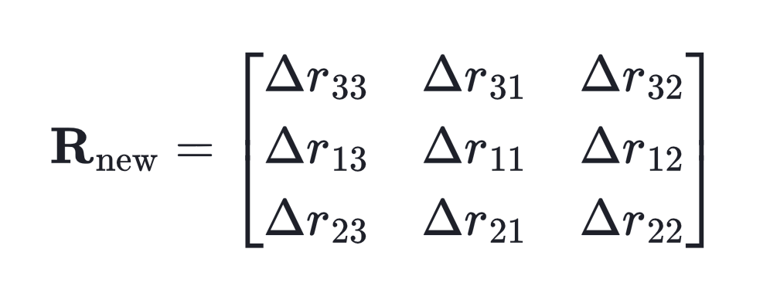
PR Transforms the covariance matrix into the difference space. $P^{T}$: Maps it back to ensure the resulting matrix represents the correlation between range differences. This operation effectively projects the absolute range noise correlations into the space of range differences. Note that that the difference operator matrix is similar to the permutation matrix that was described earlier. In addition to permuting according to the reference sensor, it also transforms the absolute ranges to range differences.
  - Difference Operator Matrix $\left(P\right)$
P$\left(N-1 x N\right)$ performs an orthogonal linear transformation of the range covariance matrix. With 1’s and -1’s it extracts the correct rows and columns for range difference measurements.
Each row of $P$ represents one range difference:
- Row 1: Sensor 1 - Sensor 3
- Row 2: Sensor 2 - Sensor 3
- Row 3: Sensor 4 - Sensor 3
- The -1 corresponds to the reference sensor contribution in each difference.


- Jacobian Sensitivity: The Jacobian Matrix $(J)$ depends on the relative geometry of the reference sensor to all other sensors. Different reference sensors interact differently with the remaining sensors because their angular and spatial relationships differ which effectively shifts their baseline for measuring range-differences.
  - Asymmetric geometry allows sensors to have a different spatial weighting in GDoP calculation. The choice of a reference sensor becomes more profound in such settings.
  - The Fischer Information Matrix (FIM) can either be more or less numerically stable based on the dynamics of a particular scenario which is controllably dictated by the choice of reference sensor.

